IPAK5 DB Structure

Table

Admin
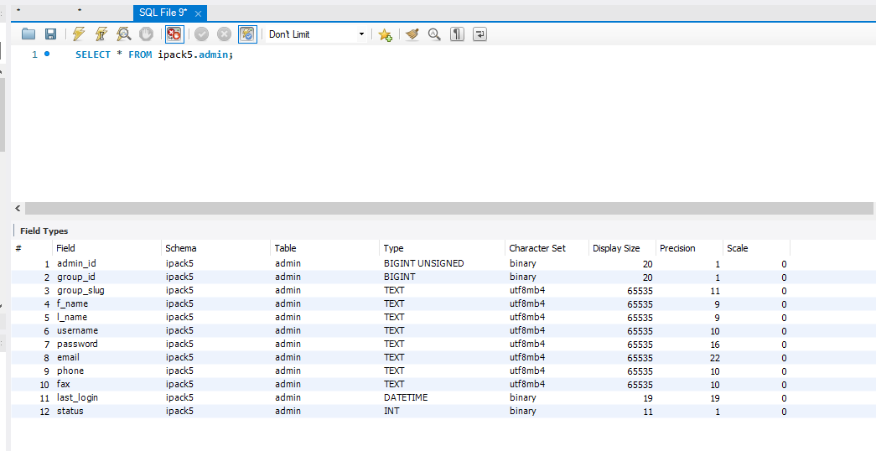

Admin Group
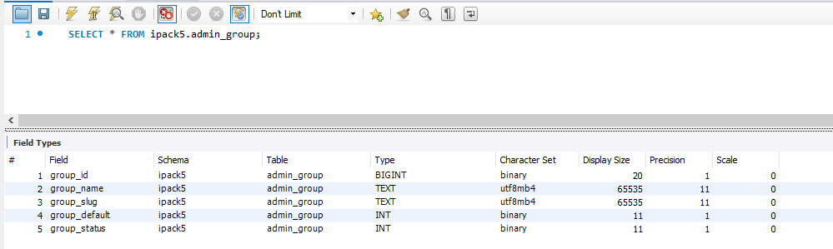

Admin Rule
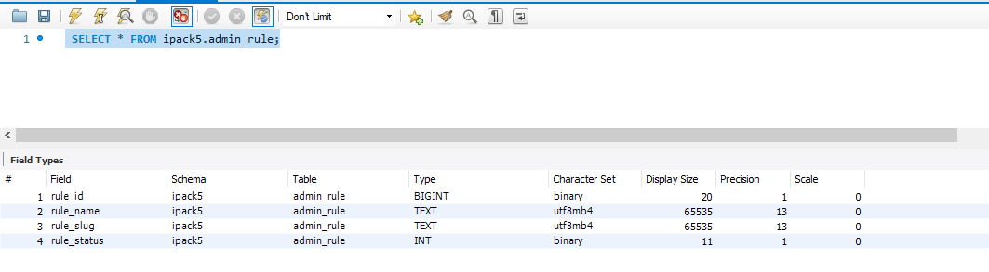

API Log
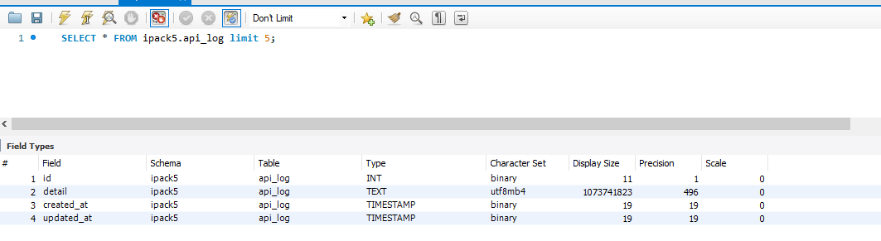

Block
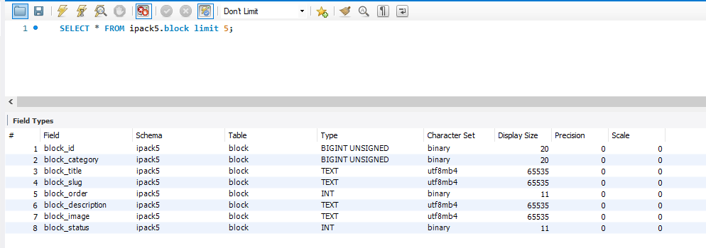

Block category
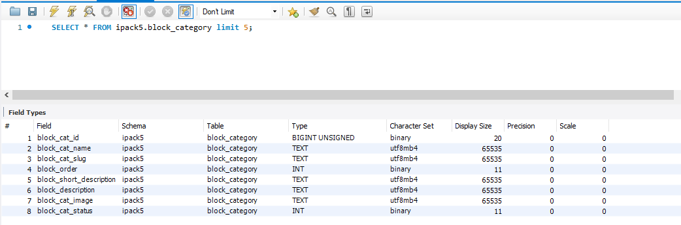

Change log
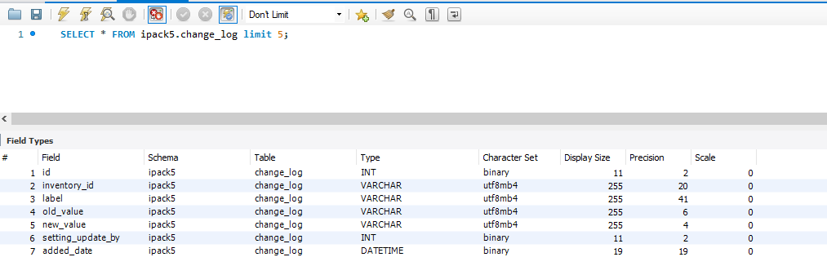

Chart Settings
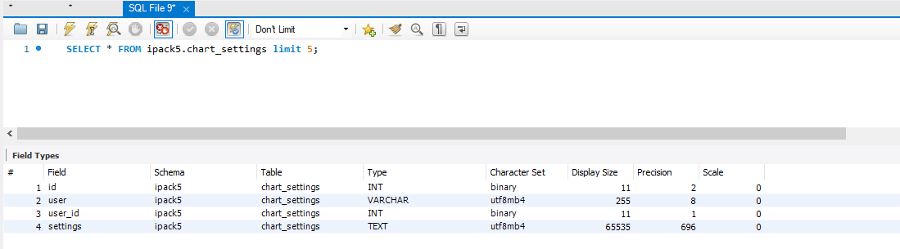

Consumption Alert
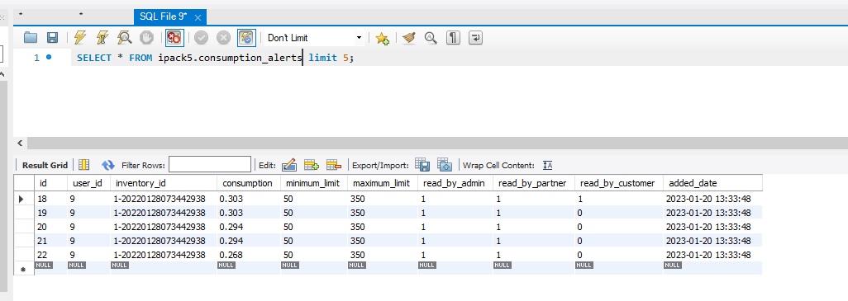

Country
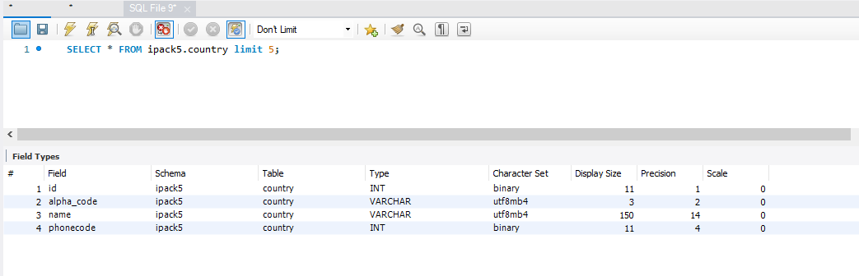

Block category

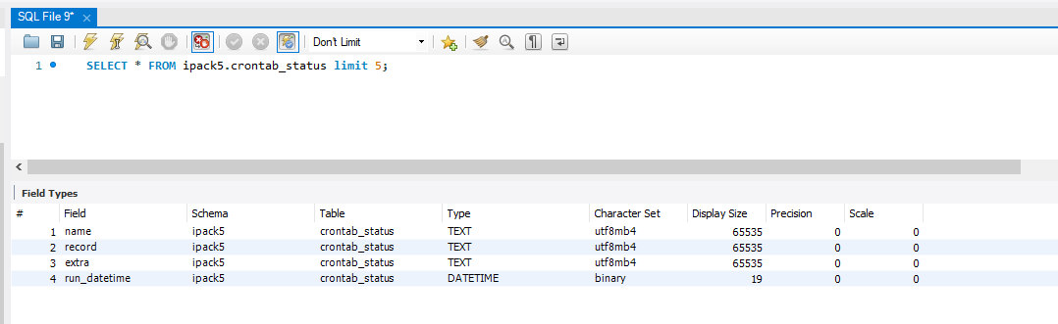

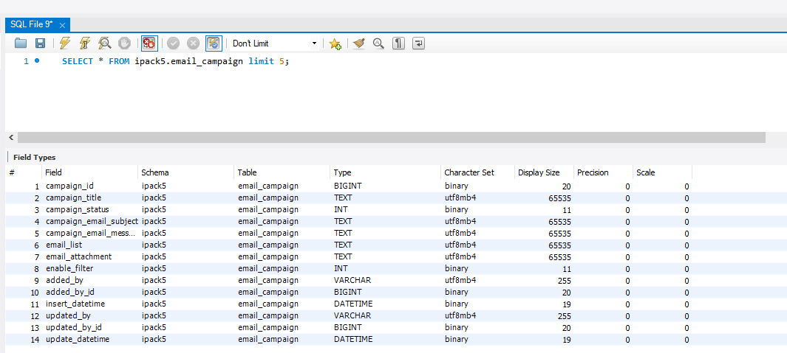

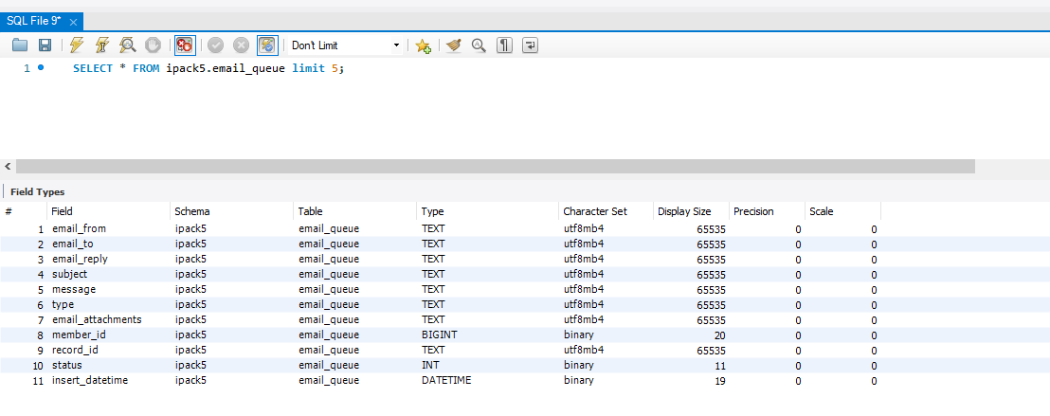
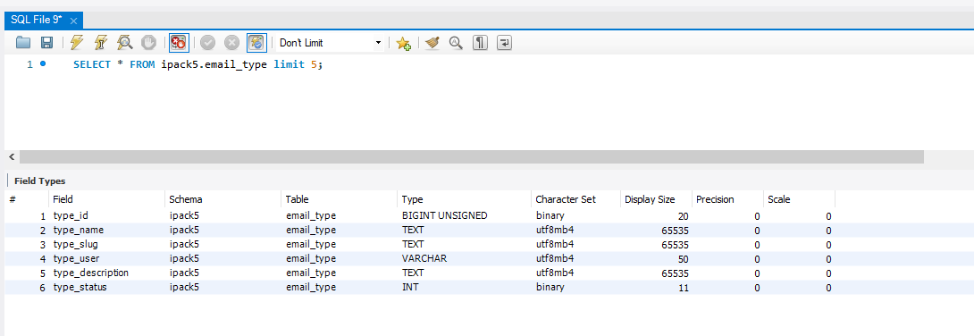
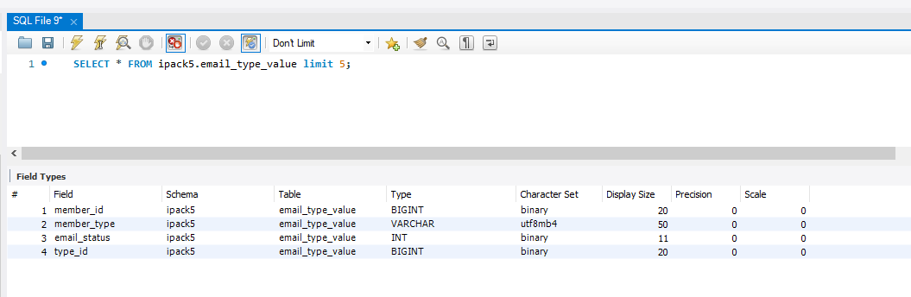
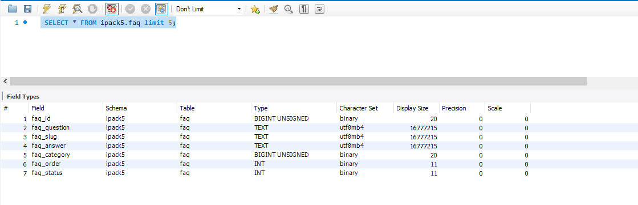

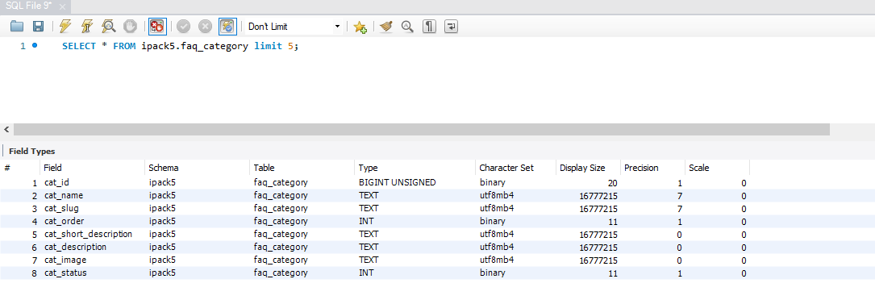

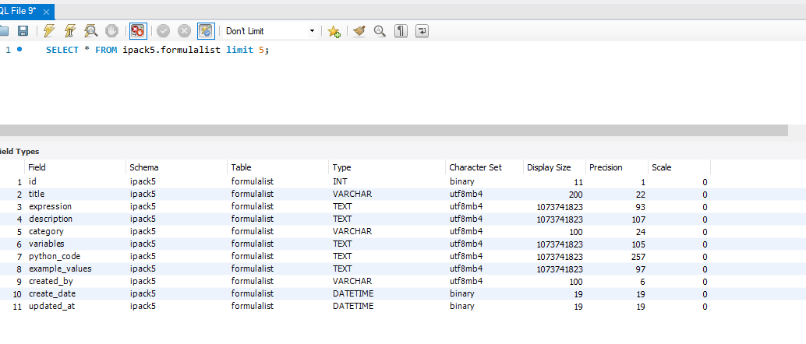
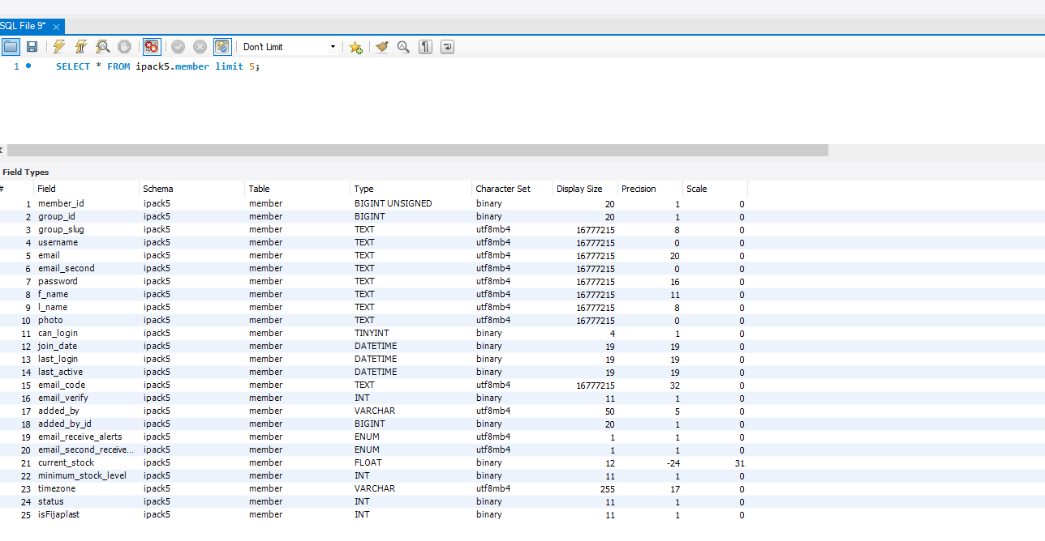
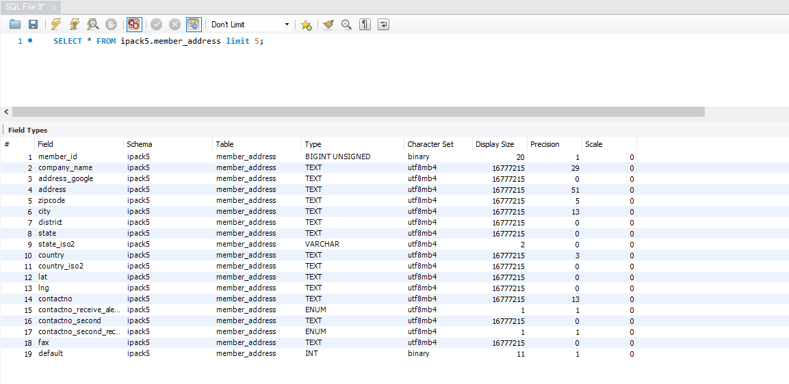
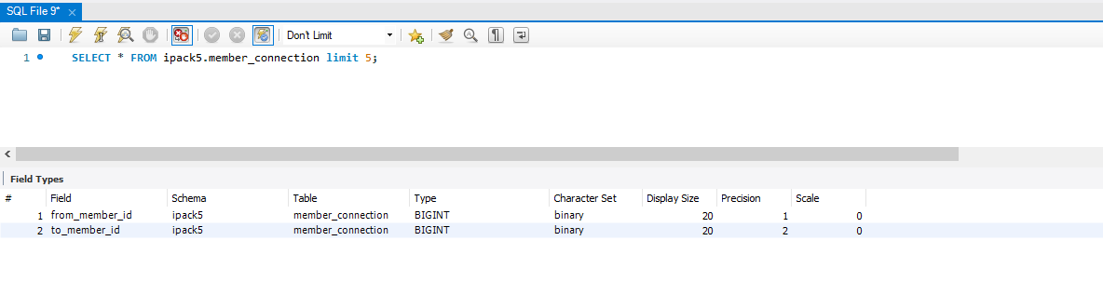
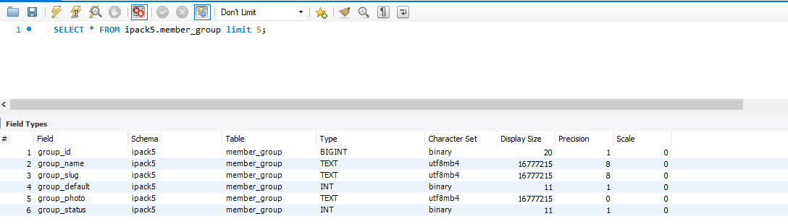
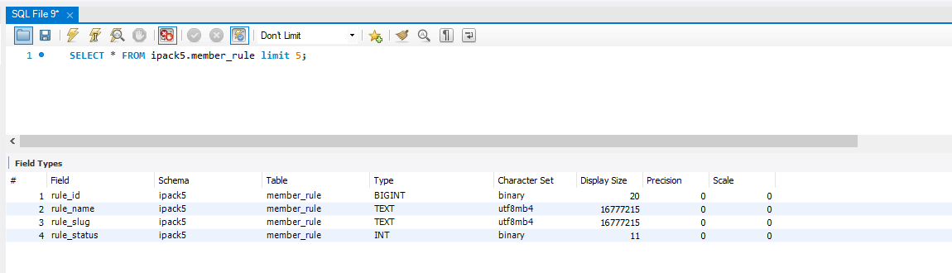
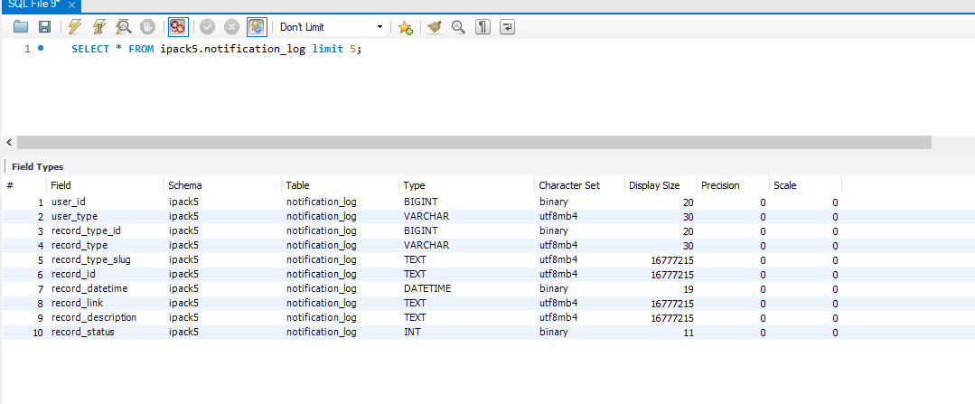
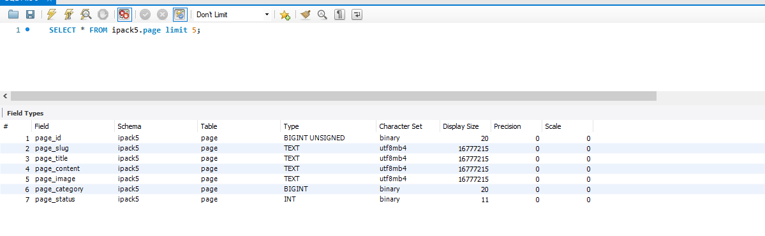
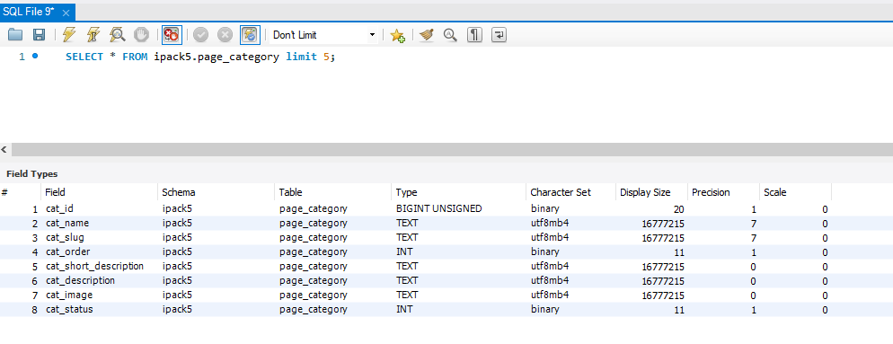
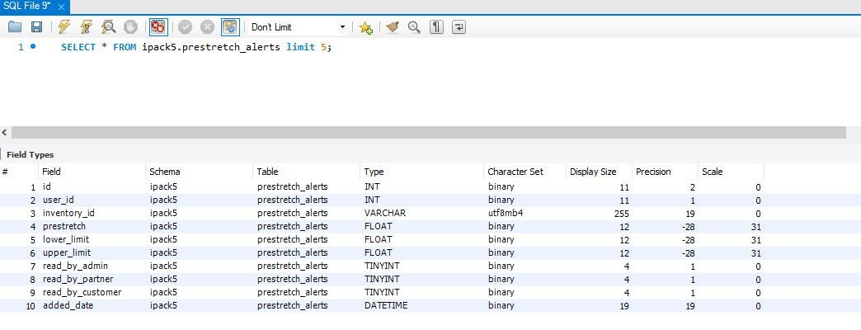
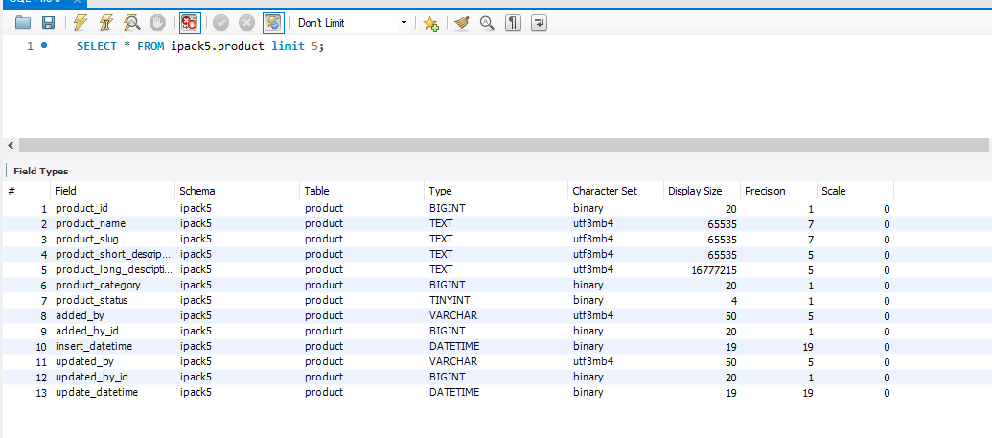

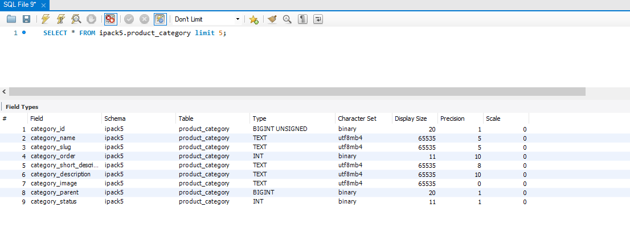
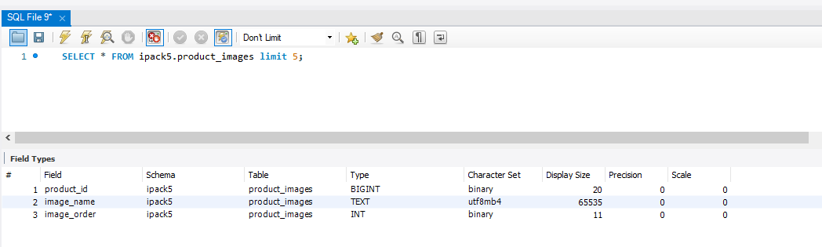
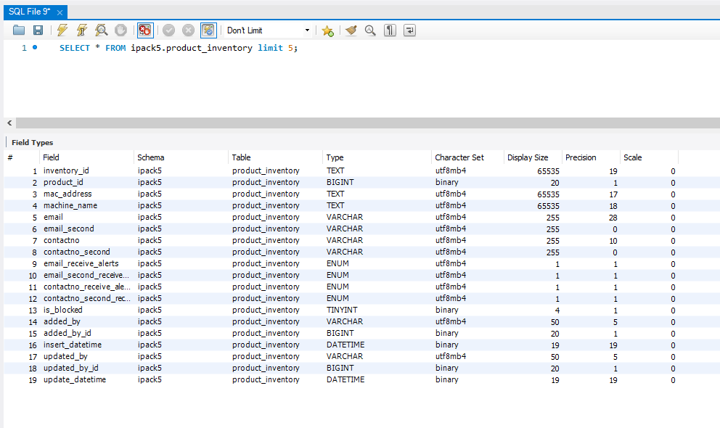
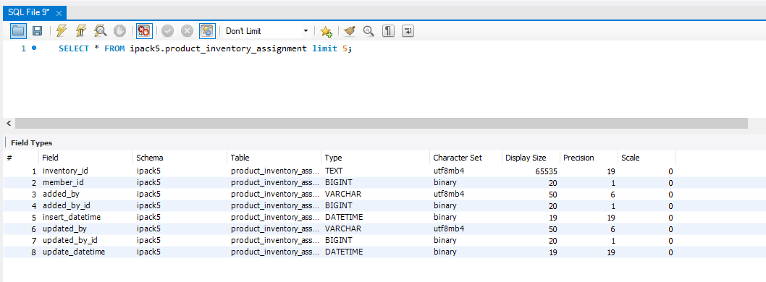
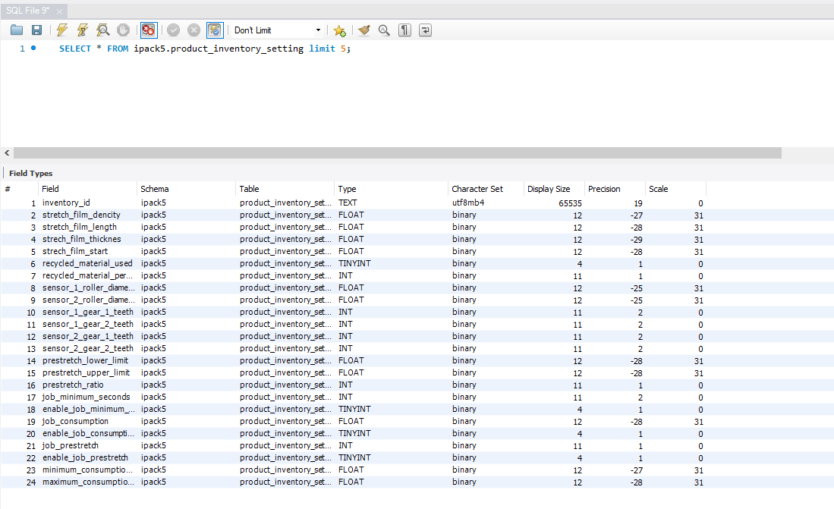
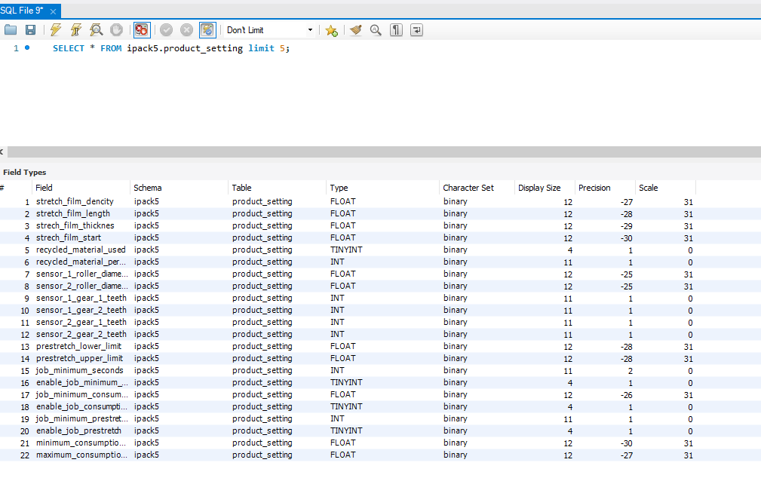
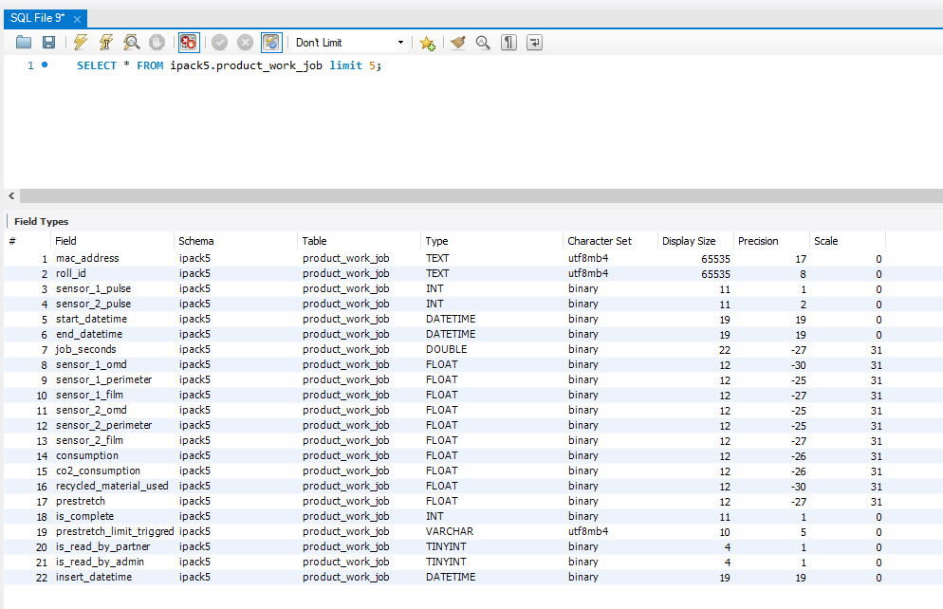
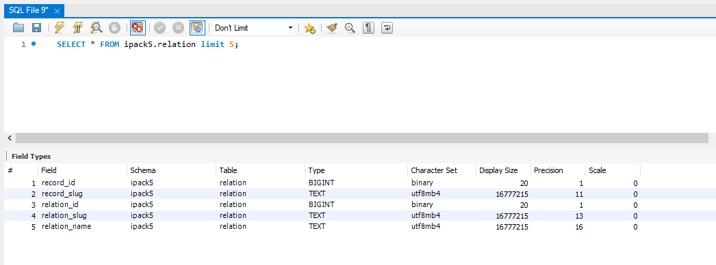
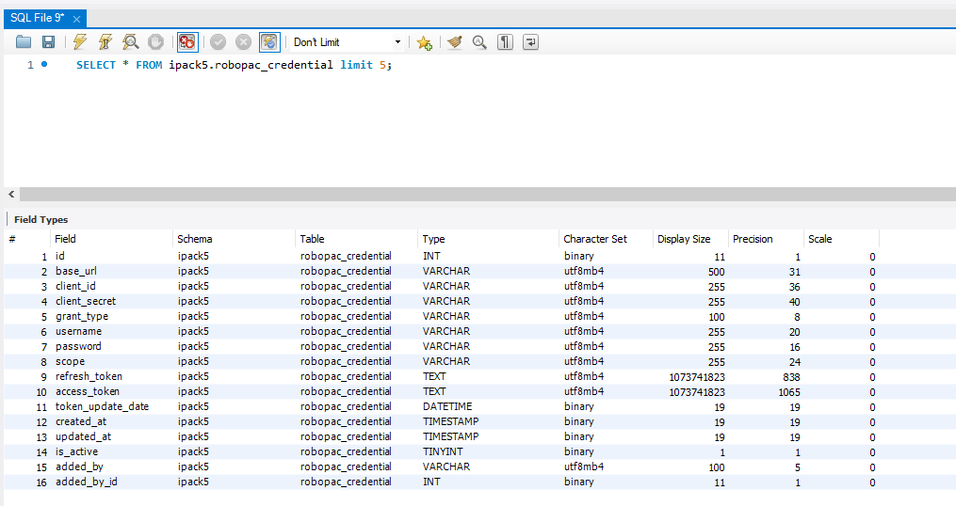
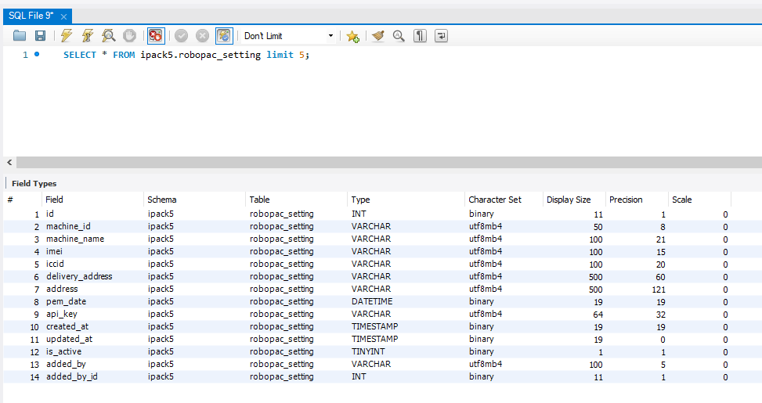
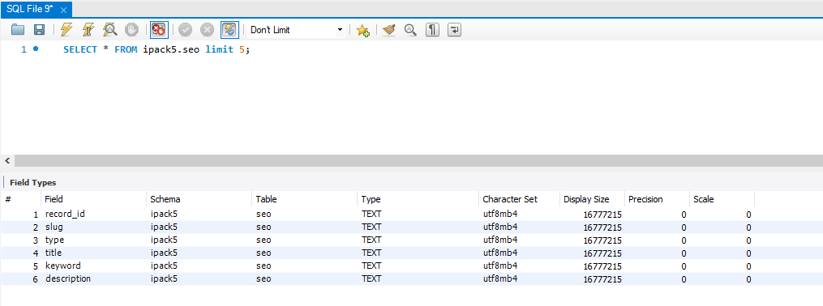
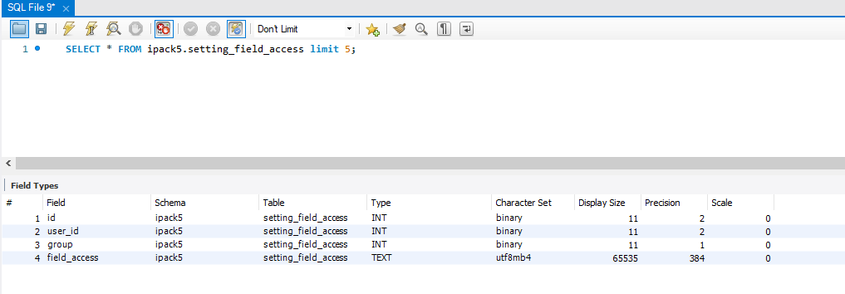
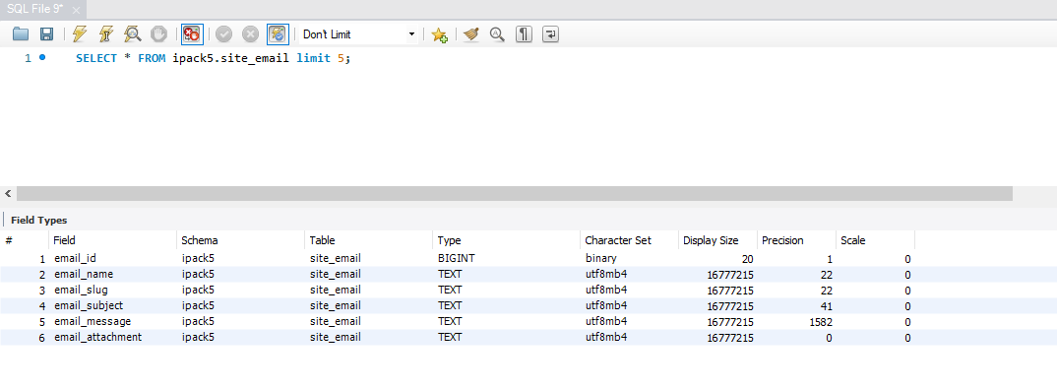
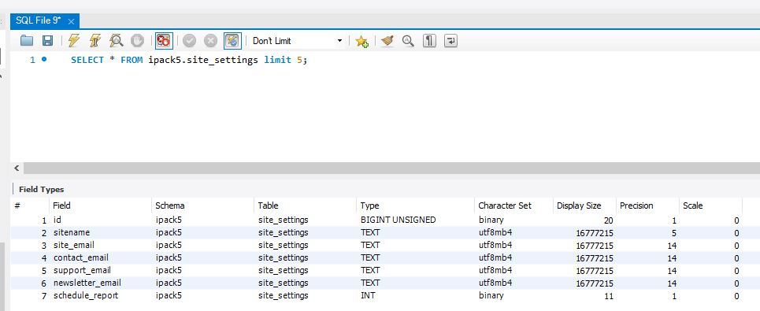
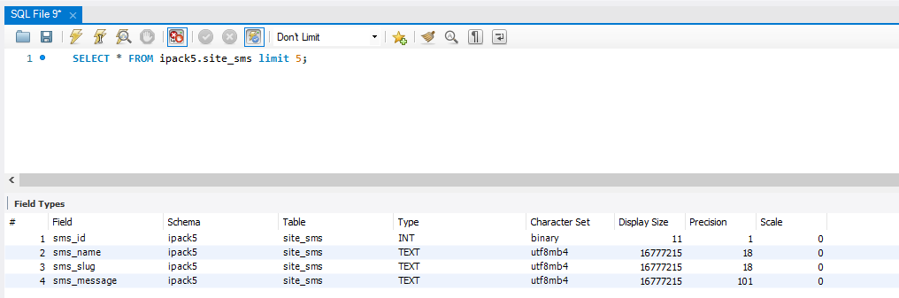
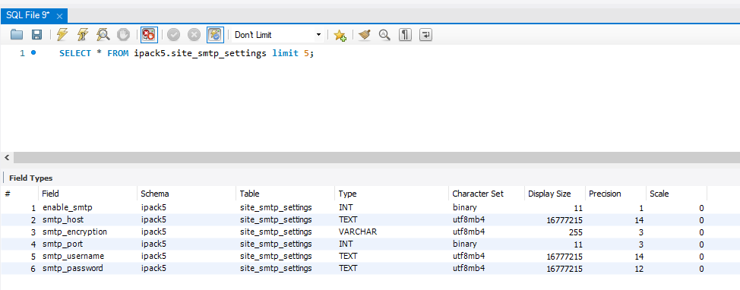
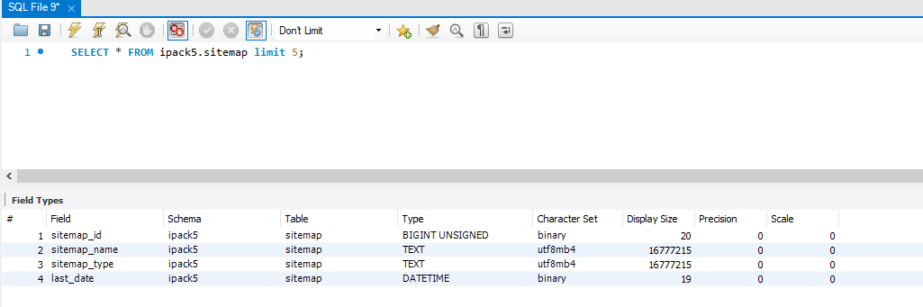
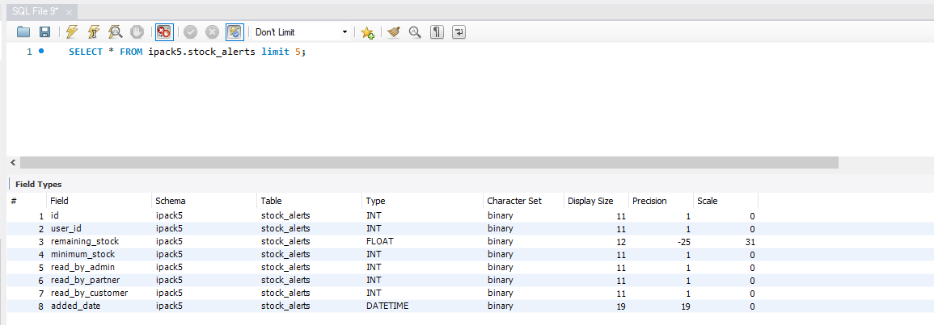
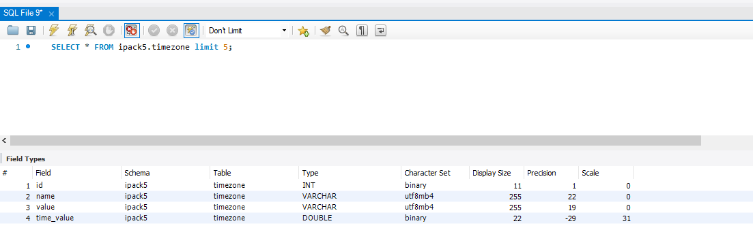

-- Backup : Live to Demo
-- TRUNCATE TABLE ipack5_demo.prestretch_alerts;
-- INSERT INTO ipack5_demo.product_work_job
-- SELECT * FROM ipack5.product_work_job;

-- Backup : Demo to Live
-- INSERT INTO ipack5.product_work_job
-- SELECT * FROM ipack5_demo.product_work_job;

-- SELECT * FROM ipack5.product_work_job order by start_datetime desc limit 10;
-- SELECT * FROM ipack5.prestretch_alerts order by added_date desc limit 10;
-- SELECT * FROM ipack5.product_work_job where mac_address = 'b8:27:eb:69:4a:04';
-- SELECT * FROM ipack5.product_inventory where mac_address = 'b8:27:eb:69:4a:04';
SELECT * FROM ipack5.product_inventory_setting where inventory_id = '1-20250429082843131';

-- Backup : Live to Demo
TRUNCATE TABLE ipack5_demo.member;
INSERT INTO ipack5_demo.member
SELECT * FROM ipack5.member;

-- Backup : Demo to Live
-- TRUNCATE TABLE ipack5.robopac_setting;
-- INSERT INTO ipack5.robopac_setting
-- SELECT * FROM ipack5_demo.robopac_setting;

SELECT * FROM ipack5.robopac_setting;

-- ------------------------------------------------------------------

-- Verify
SELECT * FROM ipack5.robopac_credential;

